**DEVKI MAHAVEER MEDICAL COLLEGE & RESEARCH HOSPITAL**

**Garhwa, Jharkhand**

**Alternate source of Energy (7.1.3)**

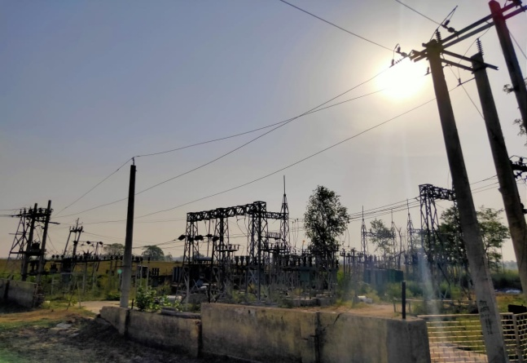 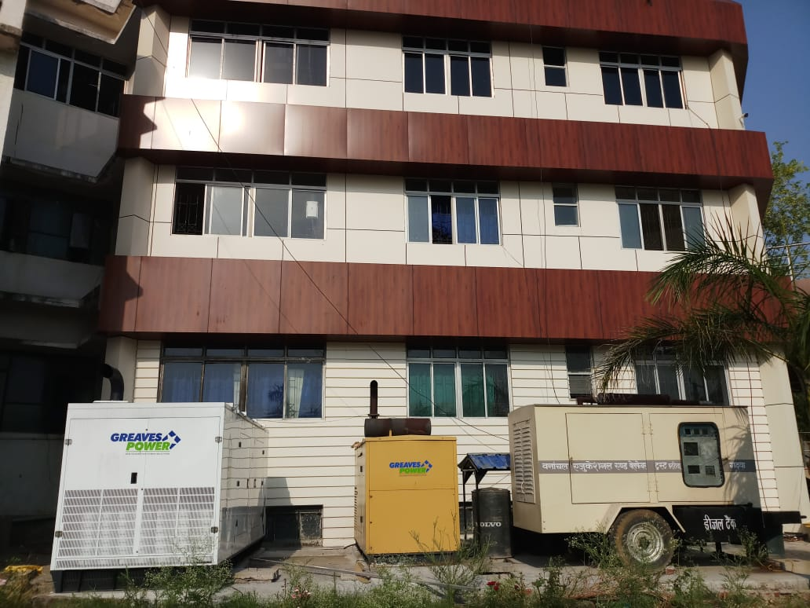

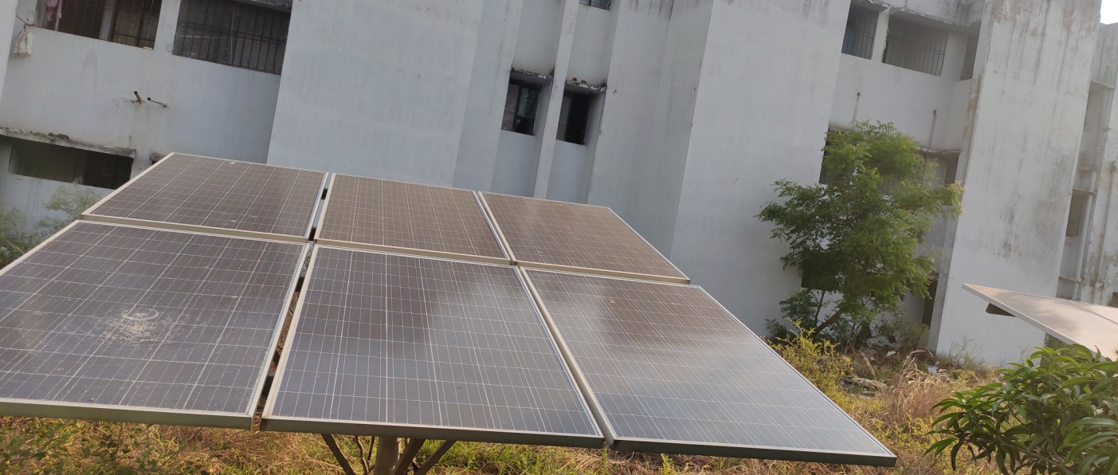

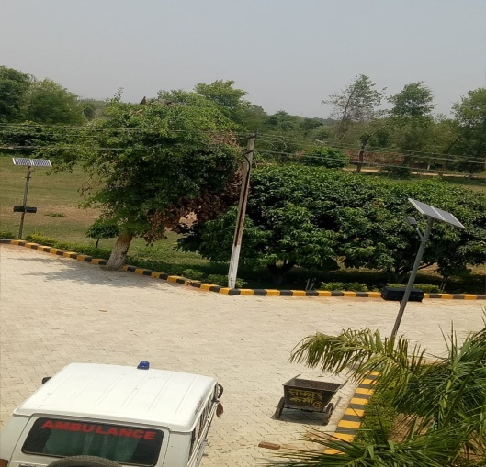 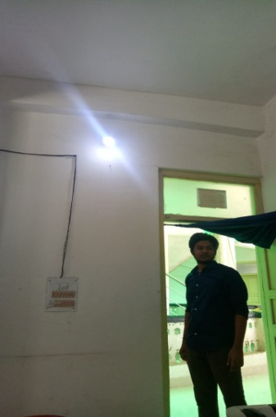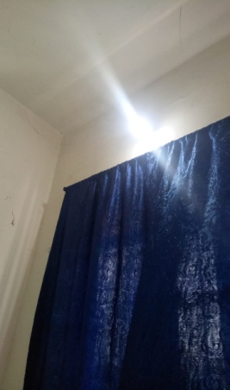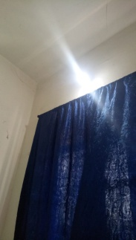

**DEVKI MAHAVEER MEDICAL COLLEGE & RESEARCH HOSPITAL**

**Garhwa, Jharkhand**

**Waste Management system (7.1.4)**

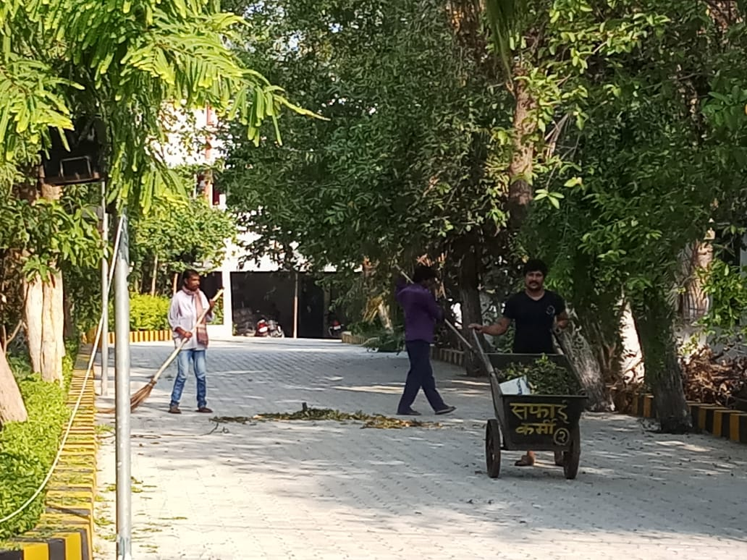

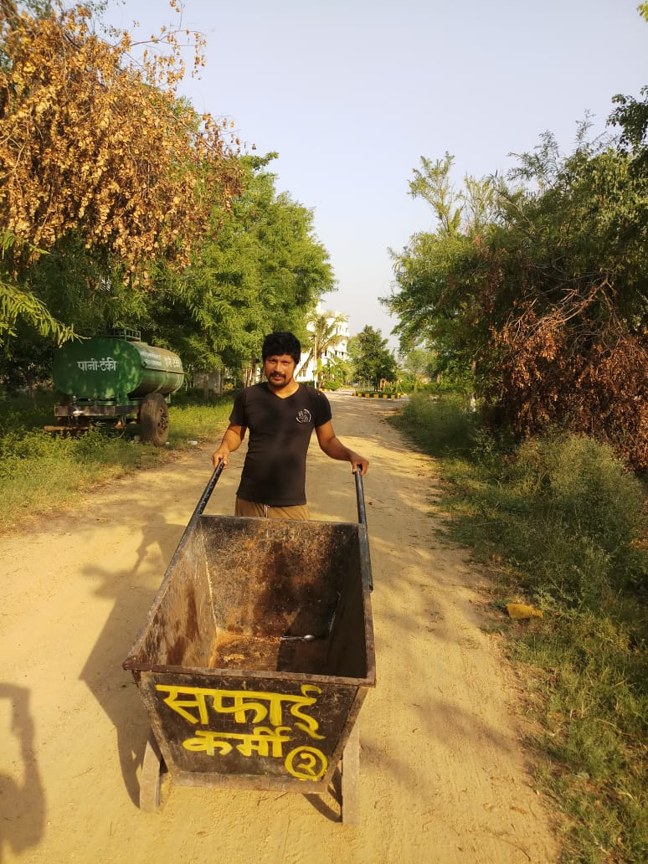 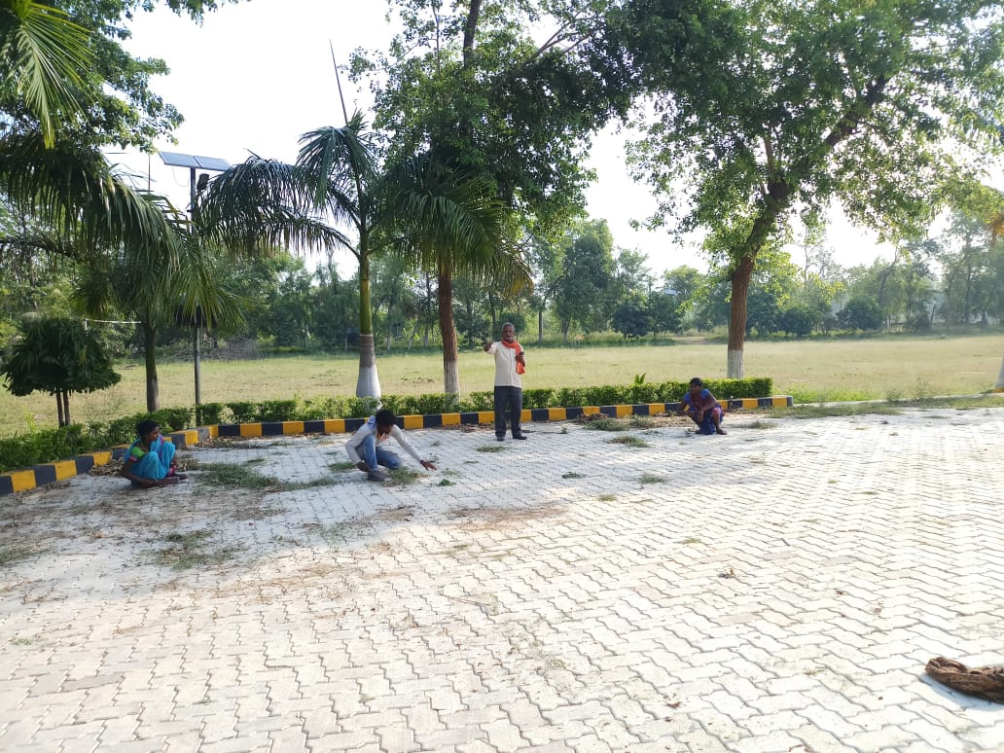

**DEVKI MAHAVEER MEDICAL COLLEGE & RESEARCH HOSPITAL**

**Garhwa, Jharkhand**

**Water Harvesting (7.1.5)**

